User 5 —
AI Photo Check and AI Video Check
User Story
As a pet owner, I often cannot understand my pet’s body language. For example, when a cat crouches in a loaf position, I cannot easily tell whether it is simply resting or feeling unwell. Although the existing AI Photo Check can help identify skin conditions and obvious wounds, I also hope the product can assess the pet’s health status based on its body movements and abnormal behaviours. This helps me decide whether to keep observing the pet, perform a physical check, or even take it to a veterinary clinic.
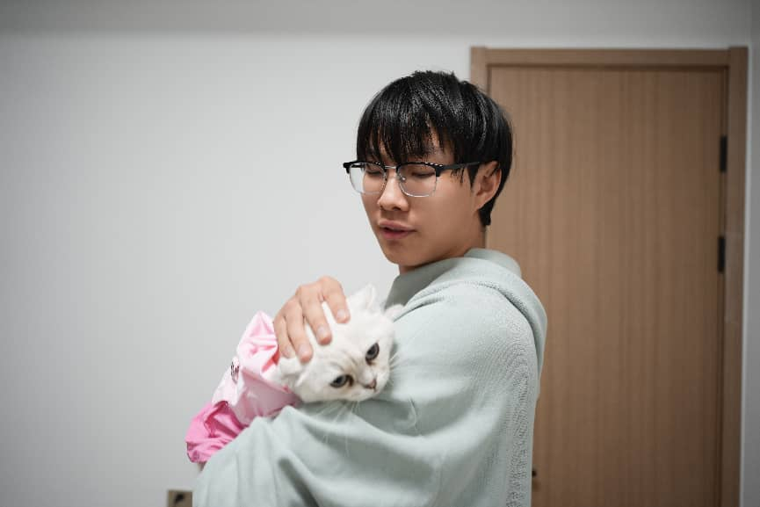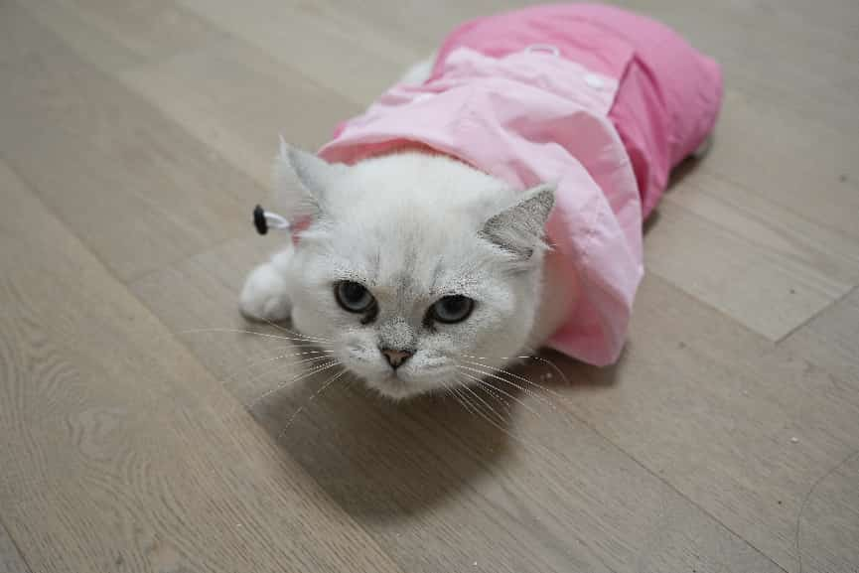
User Activity
·The user was asked to imagine their pet showing subtle health symptoms, or that they suspected the pet was unwell but could not identify the exact cause.
·We showed the user the page of the existing AI Photo Check function.
·The user experienced the function and used AI Photo Check to identify a case of fungal infection.
·The user was asked whether the feedback wording from AI Photo Check sounded like general health suggestions or definitive medical diagnosis.
·The user was asked to evaluate whether the current functions could meet daily pet healthcare needs.

User Validation Criteria
Indicator | Target / Criteria
Function Coverage Understanding | The user can clarify that AI Photo Check is mainly designed to identify visible issues, such as skin abnormalities, wounds and fungal infections.
Function Gap Identification | The user can point out that photo analysis alone is insufficient to detect behavioural abnormalities or hidden health problems in pets.
New Feature Demand Confirmation | The user recognises that video-based behaviour analysis is valuable for daily pet healthcare, with a practicality score of at least 4 out of 5.
Action Clarity | After receiving AI behaviour analysis prompts, the user can clearly state that they will continue observing the pet, conduct physical checks, or consult a veterinarian when necessary.
Risk Control Evidence | If the user regards AI outputs as definitive diagnosis rather than auxiliary suggestions, the wording of health feedback still needs optimisation.
Quotation Evidence | At least one direct user comment is recorded, stating that photo analysis cannot cover behavioural issues or expressing the expectation for abnormal behaviour recognition.

User Feedback
Before optimisation, User 5 agreed that AI Photo Check was helpful for identifying skin problems, fungal infections and visible wounds, but it could not cover all daily health concerns.
The user pointed out that many potential pet health issues do not appear directly on the skin, but are reflected in behavioural changes. For instance, loaf crouching, frequent ear scratching, abnormal lying postures or reduced activity are difficult for ordinary owners to distinguish as normal habits or health anomalies.
This revealed an obvious functional gap in the current AI Assistant: it could analyse visible problems in static photos, but could not help owners interpret health signals reflected in pets’ continuous behaviours.

Quantitative evidence before optimization:
Indicator | Before Optimisation
AI Analysis Type | Only AI Photo Check supported
Recognisable Issue Types | Mainly skin problems, obvious wounds and fungal infections
Abnormal Behaviour Recognition | Not available
User Satisfaction Score on Daily Healthcare Coverage | Relatively low / To be collected from user ratings
User Demand for Video Behaviour Analysis | Yes

Iteration Result
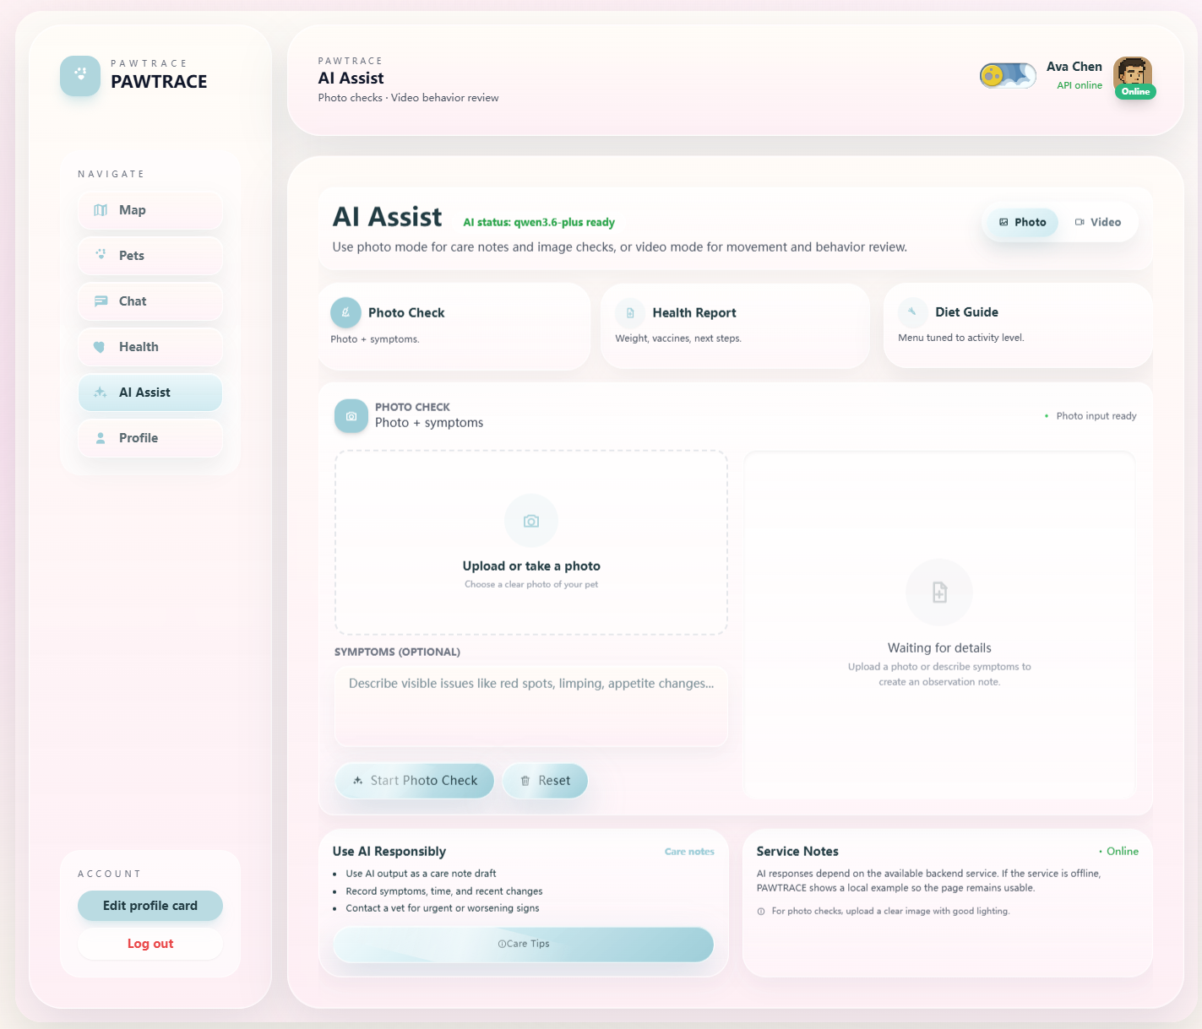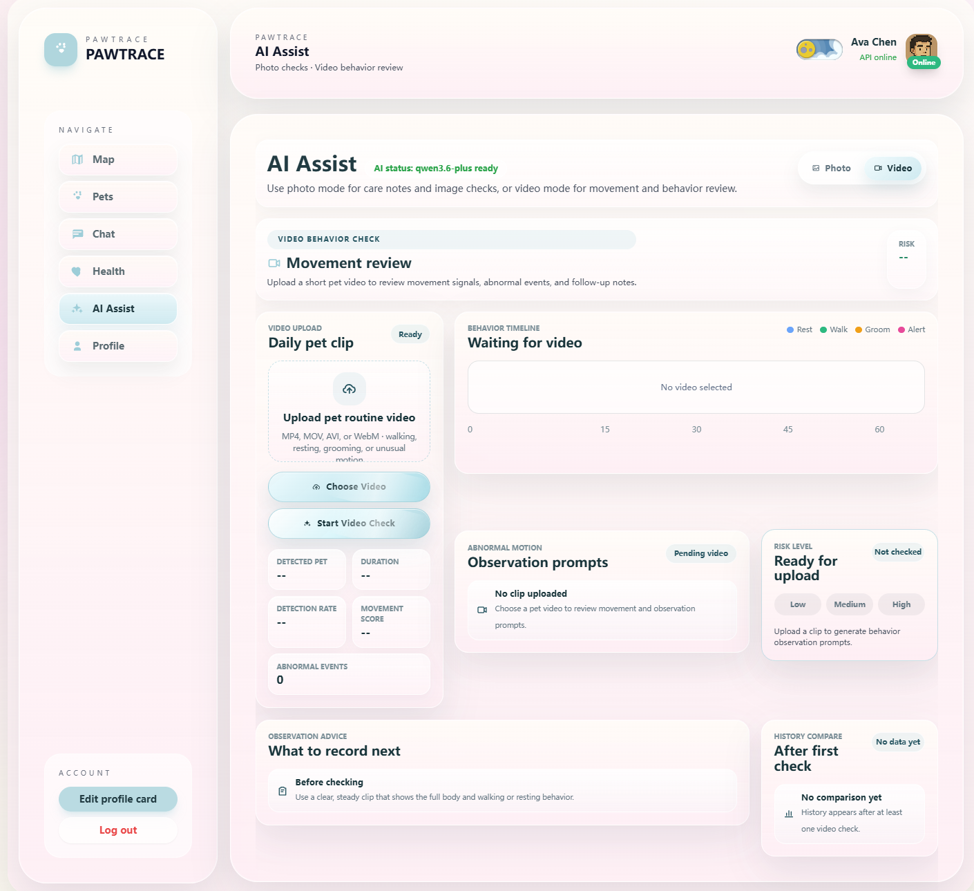
Key iteration: A new YOLO-based video behaviour analysis function named AI Video Check was added.
This feature allows users to upload self-recorded pet videos. The system identifies potential abnormal behaviours based on the pet’s movements and behavioural changes in the video, such as frequent ear scratching, abnormal lying postures, loaf crouching and reduced activity, and provides corresponding health-related suggestions and reminders.
After optimisation, the AI analysis module no longer relies solely on static photos to detect visible symptoms. It is expanded into two integrated functions:
- AI Photo Check — identifies skin problems, wounds and visible physical abnormalities.
- AI Video Check — analyses behavioural changes and hidden health signals of pets.
Quantitative evidence after optimization:
Indicator | After Optimisation
AI Analysis Type | AI Photo Check + AI Video Check
Abnormal Behaviour Recognition | Newly added YOLO-based video behaviour analysis
Coverable Health Signals | Visible skin problems + continuous behavioural abnormalities
Practicality Score Target of AI Video Check | ≥4/5
Action Clarity Target | At least 3 out of 4 users understand they should observe the pet, conduct checks, or contact a veterinarian next
In the final DemoDay version, both functions are integrated into the AI Assistant page. This iteration makes the health assistant better fit daily pet care scenarios. Pet owners need not only to spot external wounds, but also to understand those unspoken behavioural signals from their pets.

